




Digital Design Verification FYP/Internship Program
Review of C constructs

Lab # 02

Name: Abdul Hadi Afzal
Date: 25-02-2025

Table of Contents
TASK 1: 3
TASK 2: 3
TASK 3: 4
TASK 4: 6
TASK 5: 6
TASK 6: 8
Flow Chart: 11
Conclusion: 12

TASK 1:
CODE:
/****************************************************
* Author: AbdulHadi Afzal
* Task: Treasure Hunt Simulation
****************************************************/

#include <stdio.h>
#include <stdlib.h>
#include <time.h>

int main() {
int xt, yt; // Treasure coordinates

// Seed the random number generator
srand(time(0));

// Generate random coordinates for the treasure (between 1 and 4)
xt = (rand() % 4) + 1;
yt = (rand() % 4) + 1;

printf("Searching for treasure...\n");

// Searching the grid
for (int x = 1; x <= 4; x++) {
for (int y = 1; y <= 4; y++) {
printf("Checking location (%d, %d)...\n", x, y);
if (x == xt && y == yt) {
printf("Hurrah! I have found the hidden treasure at (%d, %d)!\n", xt, yt);
return 0;
}
}
}

return 0;
}

SS:
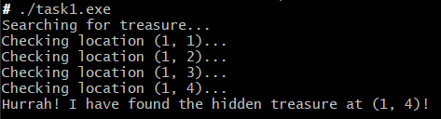

TASK 2:
CODE:

/****************************************************
* Author: AbdulHadi Afzal
* Task: Stopwatch Simulation
****************************************************/

#include <stdio.h>
#include <unistd.h>
#include <windows.h>

int main() {
int minutes;

printf("Enter the number of minutes: ");

if (scanf("%d", &minutes) != 1) {
printf("Invalid input! Please enter an integer value.\n");
return 1;
}

// Simulating the stopwatch
for (int m = 0; m < minutes; m++) {
for (int s = 0; s < 60; s++) {
printf("\r%02d:%02d", m, s);
fflush(stdout);
Sleep(1000);
}
}

printf("\nStopwatch finished!\n");
return 0;
}

SS:
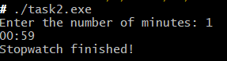

TASK 3:
CODE:
/****************************************************
* Author: AbdulHadi Afzal
* Task: Checksum Validation for Data Integrity
****************************************************/

#include <stdio.h>

int main() {
int n, i, checksum = 0, received_checksum, calculated_checksum = 0;

printf("Enter the number of bytes in the data packet: ");
scanf("%d", &n);

int data[n];

printf("Enter %d bytes (as integers):\n", n);
for (i = 0; i < n; i++) {
scanf("%d", &data[i]);
checksum ^= data[i];
}

printf("Generated Checksum: %d\n", checksum);

printf("\nReceiver Side:\n");
printf("Enter the received %d bytes (including checksum):\n", n + 1);

for (i = 0; i <= n; i++) {
scanf("%d", &received_checksum);
calculated_checksum ^= received_checksum;
}

if (calculated_checksum == 0) {
printf("Data is CORRECT (Checksum Matched)\n");
} else {
printf("Data is CORRUPTED (Checksum Mismatch)\n");
}

return 0;
}
SS:
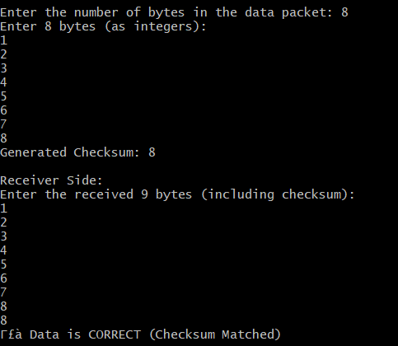

TASK 4:
CODE:

/****************************************************
* Author: AbdulHadi Afzal
* Task: Number System Converter (Decimal to Binary, Octal, Hex)
****************************************************/

#include <stdio.h>

// Function to convert and print binary representation
void printBinary(int n) {
if (n > 1)
printBinary(n / 2);
printf("%d", n % 2);
}

int main() {
int number;

printf("Enter a decimal number: ");
scanf("%d", &number);

printf("Hexadecimal: %X\n", number);
printf("Octal: %o\n", number);

printf("Binary: ");
printBinary(number);
printf("\n");

return 0;
}

SS:
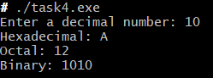

TASK 5:
CODE:
/*********************************************************
* Author: AbdulHadi Afzal
* Task: Statistical Calculator (Mean, Median, Mode, Std Dev)
*********************************************************/

#include <stdio.h>
#include <math.h>

#define SIZE 5

// Function to calculate mean
double mean(int arr[]) {
double sum = 0;
for (int i = 0; i < SIZE; i++) {
sum += arr[i];
}
return sum / SIZE;
}

// Function to calculate median
double median(int arr[]) {
for (int i = 0; i < SIZE - 1; i++) {
for (int j = 0; j < SIZE - i - 1; j++) {
if (arr[j] > arr[j + 1]) {
int temp = arr[j];
arr[j] = arr[j + 1];
arr[j + 1] = temp;
}
}
}
return arr[SIZE / 2];
}

// Function to calculate mode
int mode(int arr[]) {
int maxCount = 0, modeVal = arr[0];
for (int i = 0; i < SIZE; i++) {
int count = 0;
for (int j = 0; j < SIZE; j++) {
if (arr[j] == arr[i]) count++;
}
if (count > maxCount) {
maxCount = count;
modeVal = arr[i];
}
}
return (maxCount == 1) ? -1 : modeVal;
}

// Function to calculate standard deviation
double standardDeviation(int arr[]) {
double m = mean(arr), sum = 0;
for (int i = 0; i < SIZE; i++) {
sum += pow(arr[i] - m, 2);
}
return sqrt(sum / SIZE);
}

int main() {
int numbers[SIZE];

printf("Enter 5 numbers: ");
for (int i = 0; i < SIZE; i++) {
scanf("%d", &numbers[i]);
}

printf("Mean: %.2f\n", mean(numbers));
printf("Median: %.2f\n", median(numbers));

int modeVal = mode(numbers);
if (modeVal == -1)
printf("Mode: No mode (all numbers appear once)\n");
else
printf("Mode: %d\n", modeVal);

printf("Standard Deviation: %.2f\n", standardDeviation(numbers));

return 0;
}
SS:
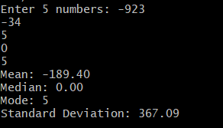

TASK 6:

CODE:
/*********************************************************
* Author: AbdulHadi Afzal
* Task: Bitwise Operations (Get, Set, Flip Bits)
*********************************************************/

#ifndef BIT_OPS_H
#define BIT_OPS_H

unsigned get_bit(unsigned x, unsigned n);
void set_bit(unsigned *x, unsigned n, unsigned v);
void flip_bit(unsigned *x, unsigned n);

#endif

#include "bit_ops.h"

// Returns the Nth bit of X
unsigned get_bit(unsigned x, unsigned n) {
return (x >> n) & 1;
}

// Sets the Nth bit of X to V
void set_bit(unsigned *x, unsigned n, unsigned v) {
if (v == 1)
*x |= (1 << n);
else
*x &= ~(1 << n);
}

// Flips the Nth bit in X
void flip_bit(unsigned *x, unsigned n) {
*x ^= (1 << n);
}

#include <stdio.h>
#include "bit_ops.h"

void test_get_bit(unsigned x, unsigned n, unsigned expected) {
unsigned a = get_bit(x, n);
if (a != expected) {
printf("get_bit(0x%08x,%u) returned 0x%08x, but we expected 0x%08x\n", x, n, a, expected);
} else {
printf("get_bit(0x%08x,%u) returned 0x%08x, correct\n", x, n, a);
}
}

void test_set_bit(unsigned x, unsigned n, unsigned v, unsigned expected) {
unsigned o = x;
set_bit(&x, n, v);
if (x != expected) {
printf("set_bit(0x%08x,%u,%u) returned 0x%08x but we expected 0x%08x\n", o, n, v, x, expected);
} else {
printf("set_bit(0x%08x,%u,%u) returned 0x%08x, correct\n", o, n, v, x);
}
}

void test_flip_bit(unsigned x, unsigned n, unsigned expected) {
unsigned o = x;
flip_bit(&x, n);
if (x != expected) {
printf("flip_bit(0x%08x,%u) returned 0x%08x, but we expected 0x%08x\n", o, n, x, expected);
} else {
printf("flip_bit(0x%08x,%u) returned 0x%08x, correct\n", o, n, x);
}
}

int main(int argc, const char *argv[]) {
printf("\nTesting get_bit()\n\n");
test_get_bit(0b1001110, 0, 0);
test_get_bit(0b1001110, 1, 1);
test_get_bit(0b1001110, 5, 0);
test_get_bit(0b11011, 3, 1);
test_get_bit(0b11011, 2, 0);
test_get_bit(0b11011, 9, 0);

printf("\nTesting set_bit()\n\n");
test_set_bit(0b1001110, 2, 0, 0b1001010);
test_set_bit(0b1101101, 0, 0, 0b1101100);
test_set_bit(0b1001110, 2, 1, 0b1001110);
test_set_bit(0b1101101, 0, 1, 0b1101101);
test_set_bit(0b1001110, 9, 0, 0b1001110);
test_set_bit(0b1101101, 4, 0, 0b1101101);
test_set_bit(0b1001110, 9, 1, 0b1001001110);
test_set_bit(0b1101101, 7, 1, 0b11101101);

printf("\nTesting flip_bit()\n\n");
test_flip_bit(0b1001110, 0, 0b1001111);
test_flip_bit(0b1001110, 1, 0b1001100);
test_flip_bit(0b1001110, 2, 0b1001010);
test_flip_bit(0b1001110, 5, 0b1101110);
test_flip_bit(0b1001110, 9, 0b1001001110);

printf("\n");
return 0;}
SS:
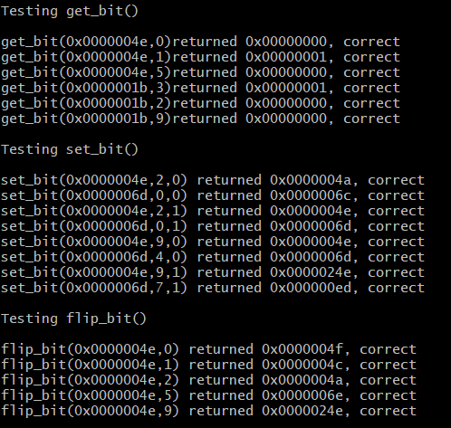

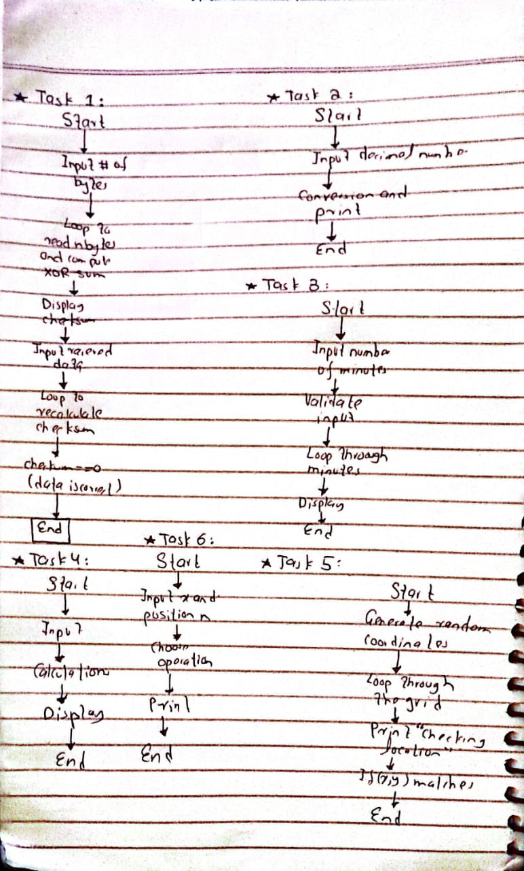

Flow Chart:

Conclusion:
In Lab 2, we explored various fundamental concepts in C programming, focusing on bitwise operations, numerical conversions, checksum validation, and interactive simulations. Each task provided hands-on experience with important programming techniques, improving our understanding of data manipulation and control structures.

